25th January 2024

Version: 9695eaa

**Software Architecture Report**

**Contents**

1. Purpose of the software project
2. How to
3. Application entry points
4. High level diagrams of the architecture
5. Deployment plan
6. External dependencies

1. **Purpose of the software project**

***PowerUp*** is a software project with a clear mission, to eliminate financial barriers to a healthy lifestyle. It focuses on personalized weight management, informative content, and community engagement. By making health accessible to all, the project combines cutting-edge technology with evidence-based information to guide users on their unique well-being journey.

At this point, the project presents user experience with registration process, a user-friendly profile management system with edit option, calculate Body Mass Index (BMI), Basal Metabolic Rate (BMR), and Total Daily Energy Expenditure (TDEE) and comment on articles.

1. **Running the project**

To run the project locally, clone this [repository](https://github.com/inginerie-software-2023-2024/proiect-inginerie-software-fit-smth).

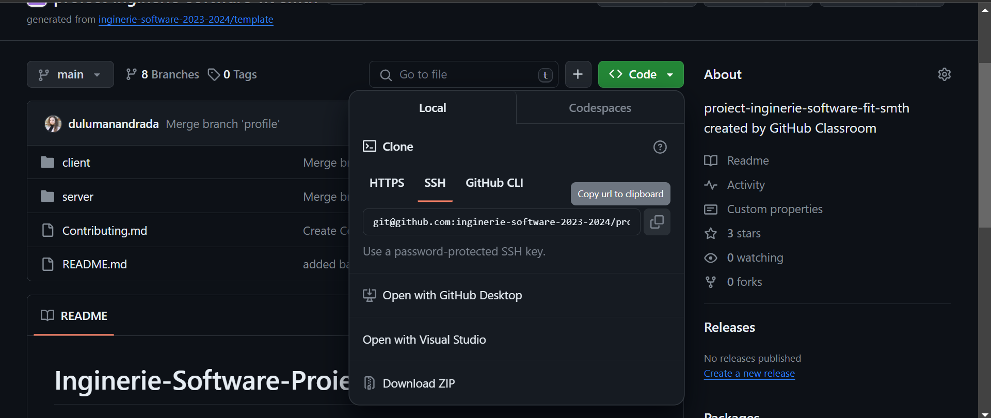

In the terminal, run ‘npm install’. After this, split the terminal: in one type *cd client* and in the other *cd server*. In each one type‘npm start’for deploying the project locally. This way is different from the regular process for backend because we add a script that uses *nodemon.*

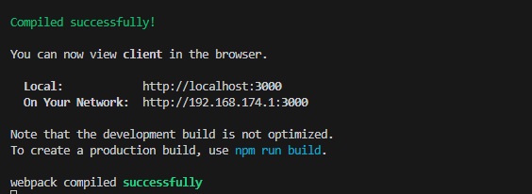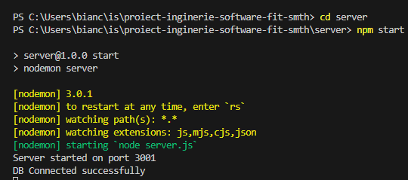 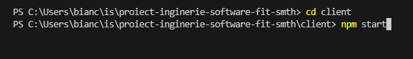

In *client*, "build": "react-scripts build" performs a series of tasks to prepare application for deployment: transpiling, bundling, minification and asset management. In *server*, "build": "npm run lint" is using ESLint which is a tool that analyzes the code for potential errors.

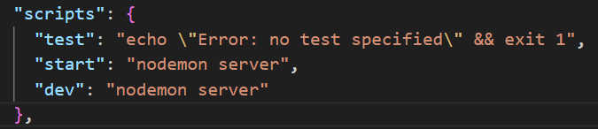

*server (backend)*

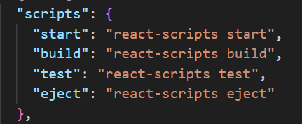

*client (frontend)*

It’s important to mention that *package.json* should be deleted and then type in the command prompt *npm install* to install all the dependencies and libraries.

The **backend server** is running on port 3001 and the **frontend server** is running on port 3000.

If you want to contribute to our software project, please check our [Contribution guide](https://github.com/inginerie-software-2023-2024/proiect-inginerie-software-fit-smth/blob/main/Contributing.md).

1. **Application entry points**

**Data sources**

* MySQL database

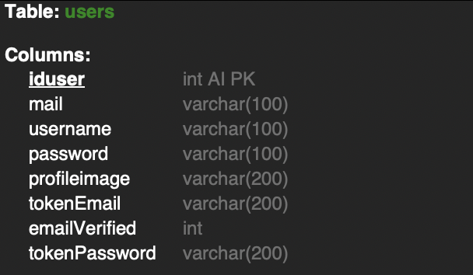

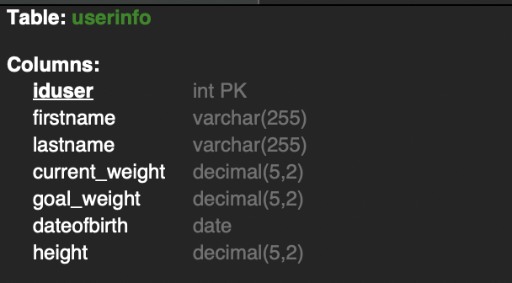

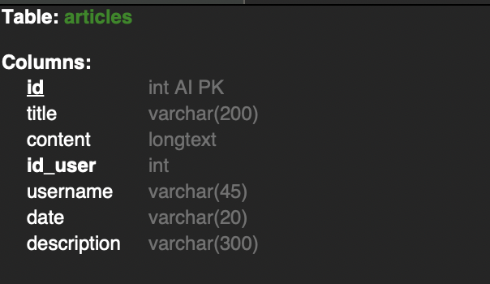

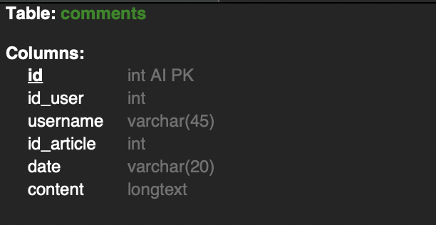

* Local Storage

**Data inputs**

* login and register forms
* calculators (BMI, BMR, TDEE)
* edit profile

**Configuration files**

* [package-lock.json](https://github.com/inginerie-software-2023-2024/proiect-inginerie-software-fit-smth/blob/main/client/package-lock.json)
  + automatically generated
  + records the exact version of each installed package and its dependencies
  + ensures that the same versions are installed across different environments
* [package.json](https://github.com/inginerie-software-2023-2024/proiect-inginerie-software-fit-smth/blob/main/client/package.json)
  + contains metadata about the project, including its name, version, description, author, and more.
  + lists project dependencies along with their allowed version ranges.
  + includes scripts, which can be executed with *npm run*
  + specifies configuration settings and other project-related information.

1. **High level diagrams of the architecture**

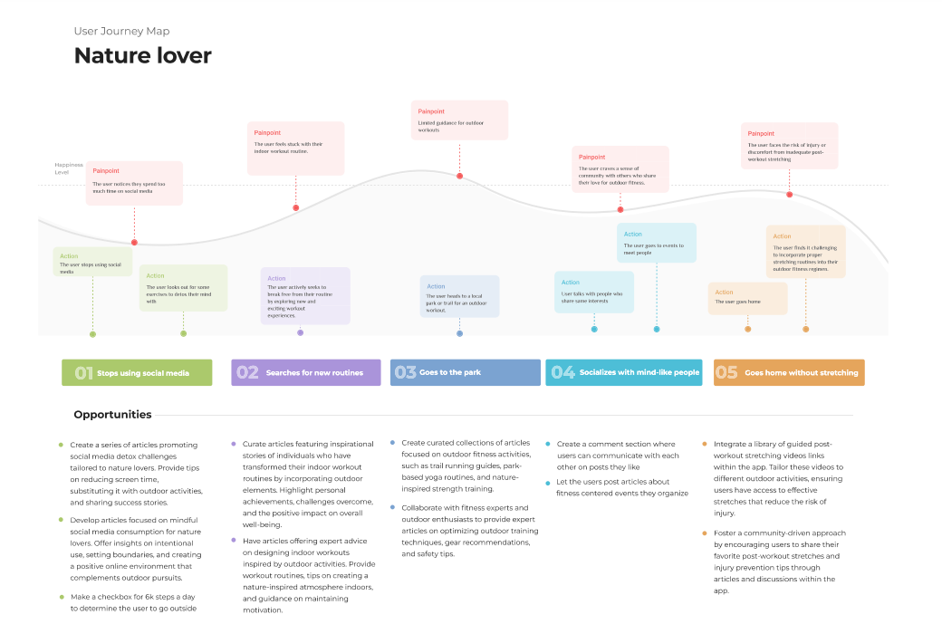

1. **Deployment plan**

**Application Components**

* Backend Server
  + The backend server runs on Node.js and is accessible at `localhost:3001`.
  + API endpoints are available for frontend communication.
* Frontend Application
  + The React frontend runs on `localhost:3000`.
  + The application interacts with the backend via API calls.
* Database
  + MySQL Workbench is used for database management.
  + The application relies on a local MySQL database.

**Local Development Setup**

* Backend
  + Start the backend server with `npm start` in the backend directory.
* Frontend
  + Run the frontend development server with `npm start` in the frontend directory.
  + Connect to the backend API at `localhost:3001`.
* Database
  + Use MySQL Workbench to connect to the local database.

**Configuration**

* Environment Variables
  + set environment variables for database connection and API endpoints.
* Local Storage:
  + the application utilizes local storage for client-side data storage.

**Database Management**

* use MySQL Workbench for database schema management
* execute queries and scripts to manage the database

For **deployment steps** and **build process** see **chapter 2****.**

1. [How the CI/CD pipeline works](https://github.com/inginerie-software-2023-2024/proiect-inginerie-software-fit-smth/tree/ci-pipeline).

1. **External dependencies**

* testing libraries:
  + jest-dom
  + react
  + user-event
* axios
* bootstrap
  + react-bootstrap
* react
  + dom
  + icons
  + router-dom
  + scripts
  + react-quill
* web vitals
* bcrypt
* cookie parser
* cors
* express
* mysql
* nodemon